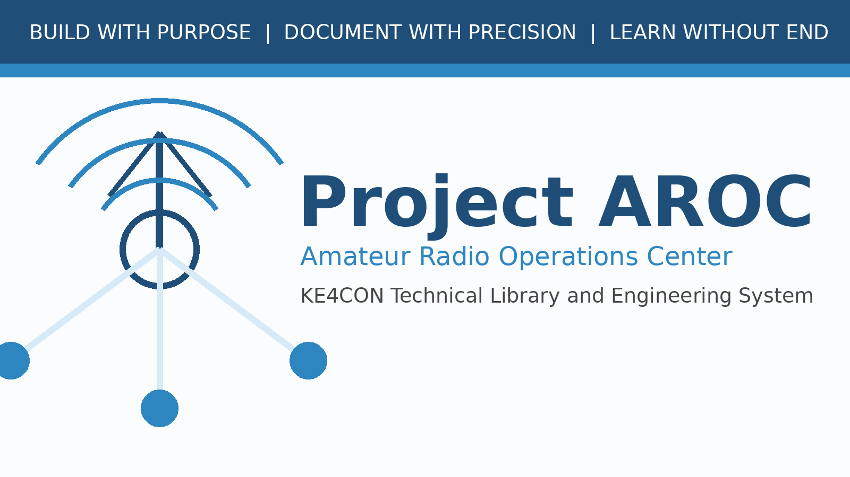

AROC-STD-0001 Publishing Standard
Milestone 0003A - Project Publishing Framework

Document Number | AROC-STD-0001
Revision | 0.1
Status | Draft for Review
Project | Project AROC - KE4CON
Motto | Build with Purpose. Document with Precision. Learn without End.

Document Control
Document Number | AROC-STD-0001
Title | Project AROC Publishing Standard
Revision | 0.1
Status | Draft for Review
Owner | James / KE4CON
Technical Author | ChatGPT
Applies To | Project AROC Technical Library and Engineering Documentation

Revision History
Revision | Date | Author | Description | Status
0.1 | 2026-06-30 | ChatGPT | Initial milestone 0003A publication framework draft | Draft

Table of Contents
1. Purpose and Scope
2. Standard Document Structure
3. Project AROC Branding
4. Typography
5. Color Palette
6. Headers and Footers
7. Standard Page Types
8. Engineering Notes
9. Design Decisions
10. Future Expansion Notes
11. Figure and Table Presentation
12. Template Usage
13. Quality Checklist
Note: In later releases, this placeholder will be replaced with an automatic Word table of contents field.

1. Purpose and Scope
This standard defines the official publishing system for Project AROC. It exists so every future Project AROC document looks, reads, and behaves like part of one coherent professional engineering library rather than a collection of unrelated files.
Engineering Note 0003A-01
The publishing framework is treated as infrastructure. Just as the Raspberry Pi, switch, and network cabling support the technical system, the publishing framework supports the documentation system. A consistent document system reduces confusion, makes updates easier, and allows the Project AROC library to grow for years without losing organization.

2. Standard Document Structure
Every formal Project AROC publication shall use the following structure unless the document type makes a section unnecessary.
- Cover page
- Copyright and usage page
- Document control page
- Revision history page
- Table of contents
- List of figures
- List of tables
- Main body
- Appendices
- Glossary, if applicable
- Index, if applicable

3. Project AROC Branding
Project AROC branding identifies every document as part of the KE4CON Amateur Radio Operations Center library. Branding shall remain consistent across PDF, Word, HTML, quick-reference, and presentation formats.
- Project name: Project AROC
- Expanded name: Amateur Radio Operations Center
- Station identity: KE4CON
- Motto: Build with Purpose. Document with Precision. Learn without End.
- Primary visual theme: professional engineering, amateur radio, network infrastructure, long-term maintainability

4. Typography
- Primary body font: Arial or Aptos, 10.5 point
- Heading font: Arial Bold or Aptos Display
- Code/configuration font: Consolas or Courier New
- Body line spacing: readable single spacing with spacing after paragraphs
- Avoid decorative fonts in technical content

5. Color Palette
Name | Hex | Usage
aroc_navy | #1F4E79 | Primary headers, cover bands, title accents
aroc_blue | #2E86C1 | Secondary accents, diagrams, link-like items
aroc_light_blue | #D6EAF8 | Callout backgrounds and table heading alternates
aroc_gray | #F2F4F4 | Document background panels
aroc_dark_gray | #444444 | Body support text and footer elements
aroc_green | #1E8449 | Success/check status
aroc_orange | #CA6F1E | Warning/attention notes
aroc_purple | #6C3483 | Future expansion notes

6. Headers and Footers
Headers identify the project, document number, and document title. Footers identify revision and ownership. Page numbers shall be included in later template revisions once final pagination is generated.
Design Decision 0003A-01
Headers and footers will be intentionally conservative. The purpose is navigation and identification, not decoration. A reader should always know which Project AROC document is open, what revision it is, and where it belongs in the library.

7. Standard Page Types
- Cover page: title, document number, revision, logo, motto
- Copyright page: ownership and usage statement
- Document control page: owner, author, status, applicability
- Revision history page: revision, date, author, description, status
- TOC page: document navigation
- List of figures and tables: used when figures/tables exist

8. Engineering Notes
Engineering Note Example
Engineering Notes explain the technical reasoning behind a topic. They are used when a reader may benefit from understanding what is happening behind the scenes.

9. Design Decisions
Design Decision Example
Design Decision boxes record why one approach was chosen over another. They preserve engineering reasoning for future review.

10. Future Expansion Notes
Future Expansion Note Example
Future Expansion Notes capture ideas that should not interrupt current work but may become valuable later.

11. Figure and Table Presentation
Figures and tables shall be numbered consistently by document or chapter. Captions shall be meaningful and shall explain what the reader is seeing. Figures must be created specifically for Project AROC whenever possible.
- Figure format: Figure <chapter>-<number>: <caption>
- Table format: Table <chapter>-<number>: <caption>
- Every diagram shall have a title and purpose
- Screenshots shall be cropped for readability and annotated when needed

12. Template Usage
Formal documents shall start from the Project AROC Master Document Template. Quick notes may be plain text, but any release-quality document shall be converted into the standard layout before publication.

13. Quality Checklist
- Cover page present
- Document control page present
- Revision history present
- Document number and revision correct
- Headers and footers applied
- Callout styles used consistently
- Figures and tables numbered if present
- PDF generated
- DOCX saved
- Release notes updated
- ZIP package created

